Reflect & Assist

Kacey Morris

CST-451 Capstone Project Requirements Document

Grand Canyon University

Instructor: Professor Mark Reha

Revision: 2.0

Date: April 24, 2022

**ABSTRACT**

The Reflect & Assist is a Raspberry Pi kit with all materials and software included to create a Smart Mirror display. This display is a mobile mirror that projects information contained in modules alongside its reflection. The Reflect & Assist kit will include the Raspberry Pi, a monitor, plexiglass, links to required GitHub modules, as well as instructions on how to set up the Raspberry Pi, install all required dependencies, and assemble the mirror set up. As a kit, those interesting in building a customizable smart mirror will find all essential resources in a centralized location, making learning programming and embedded systems simpler and more accessible.

The kit will include 14 different display modules options, including an alarm clock, weather display, a daily Bible quote, and many others, as well as access to a website for managing the individual display. To encourage creativity and expansion, access to an extended list of potential modules and a template for personalized module creation will be included as well.

|  |
| --- |
| History and Signoff Sheet |

**Change Record**

|  |  |  |
| --- | --- | --- |
| **Date** | **Author** | **Revision Notes** |
| October 24, 2021 | Kacey Morris | Initial draft for review/discussion |
| April 24, 2022 | Kacey Morris | Color coded NFR and FR excel document while completing requirements throughout semester, updated user interface design |
|  |  |  |

|  |
| --- |
| **Overall Instructor Feedback/Comments** |

|  |
| --- |
| **Overall Instructor Feedback/Comments** |

**Integrated Instructor Feedback into Project Documentation**

Yes  No

**TABLE OF CONTENTS**

Functional Requirements 4

Non-Functional Requirements 5

Technical Requirements 6

Logical System Design 7

User Interface Design 8

Reports Design 9

Functional Requirements

**User Stories**

Please reference the Excel document labeled “FunctionalAndNFR” for User Stories detailing the functional requirements.

Non-Functional Requirements

**User Stories**

Please reference the Excel document labeled “FunctionalAndNFR” for User Stories detailing the non-functional requirement. These User Stories will contain “**NFR**” preceding the feature description.

Technical Requirements

Many of the tools and technologies used in this project come preinstalled from the Raspberry Pi Starter Kit.

|  |  |  |
| --- | --- | --- |
| **Technology or Tool** | **Approval Date** | **Justification** |
| Raspberry Pi 4 Model B | October 5, 2021 | This Pi can physically handle the required functionality. |
| Raspberry Pi OS (AKA Raspbian) v5.10 | October 7, 2021 | Installed through NOOBS that came with the starter kit. |
| Apache2 v2.4.51 | October 24, 2021 | This will allow the management site to be hosted locally. Only the user will be manipulated their individual mirror. |
| PHP v7.4 | October 24, 2021 | PHP will be used to program the management site. |
| Geany IDE v1.38.0 | October 12, 2021 | Python and PHP development are possible with this IDE. |
| MariaDB v10.6.5 | October 24, 2021 | This is a MySQL database that will work well with PHP and Apache. |
| phpMyAdmin v5.1.1 | October 24, 2021 | This will allow for database creation and manipulation through UI. |
| Python v3.7.3 | October 12, 2021 | Python will be used to create and manipulate the modules that will be displayed on the mirror surface. |

Logical System Design

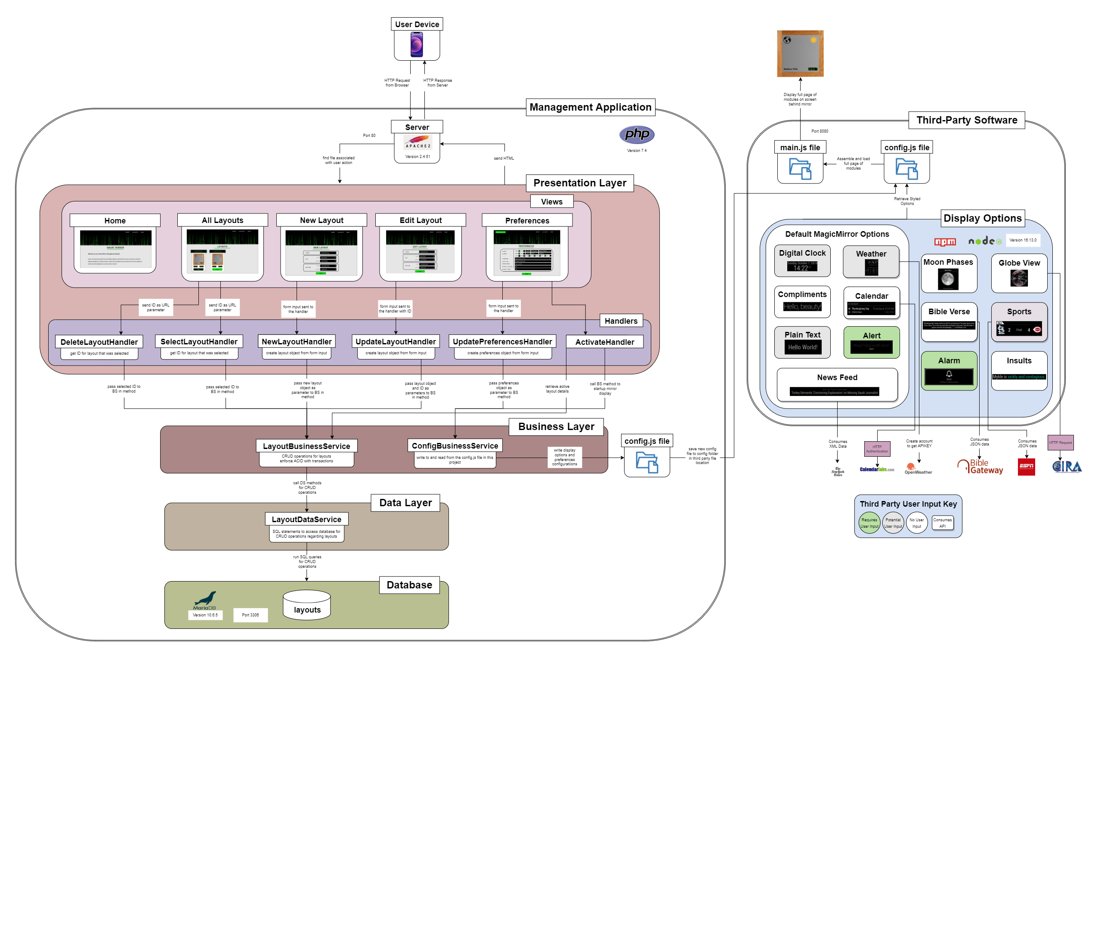

*This is the logical solution block diagram which details the layout of the applications. It includes all technology utilized within the design, interface designs, actions, and interactions between components of the system.*

User Interface Design

Sitemap:

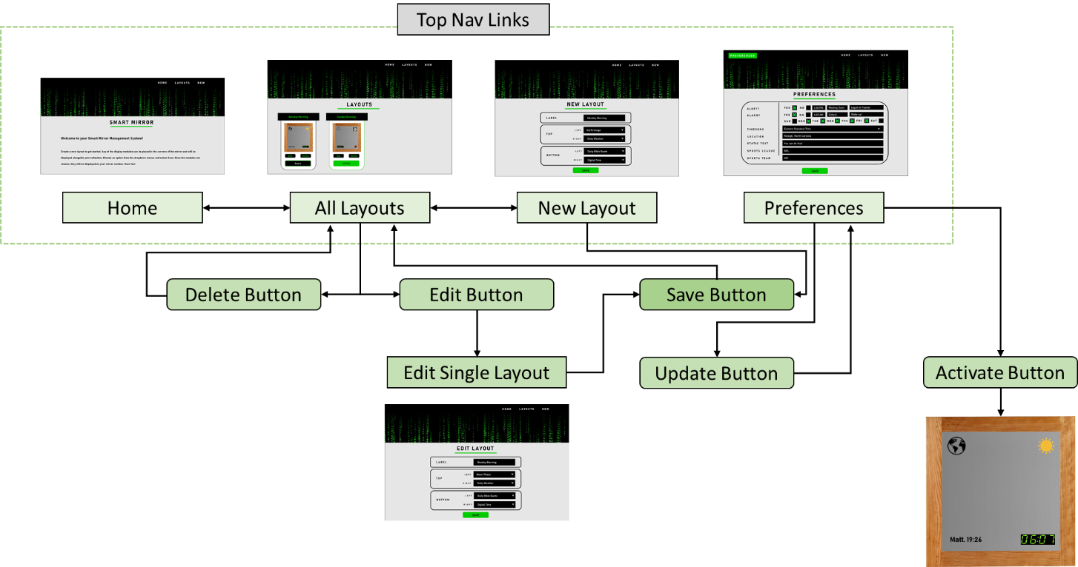

*Sitemap diagram detailing the interactions between each page through link and button clicks.*

Home Page:

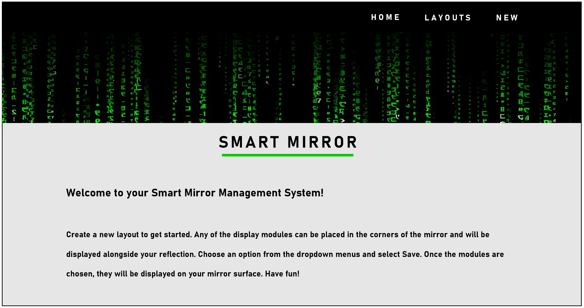

*The proposed home page layout and content for the management application.*

View All Saved Layouts:

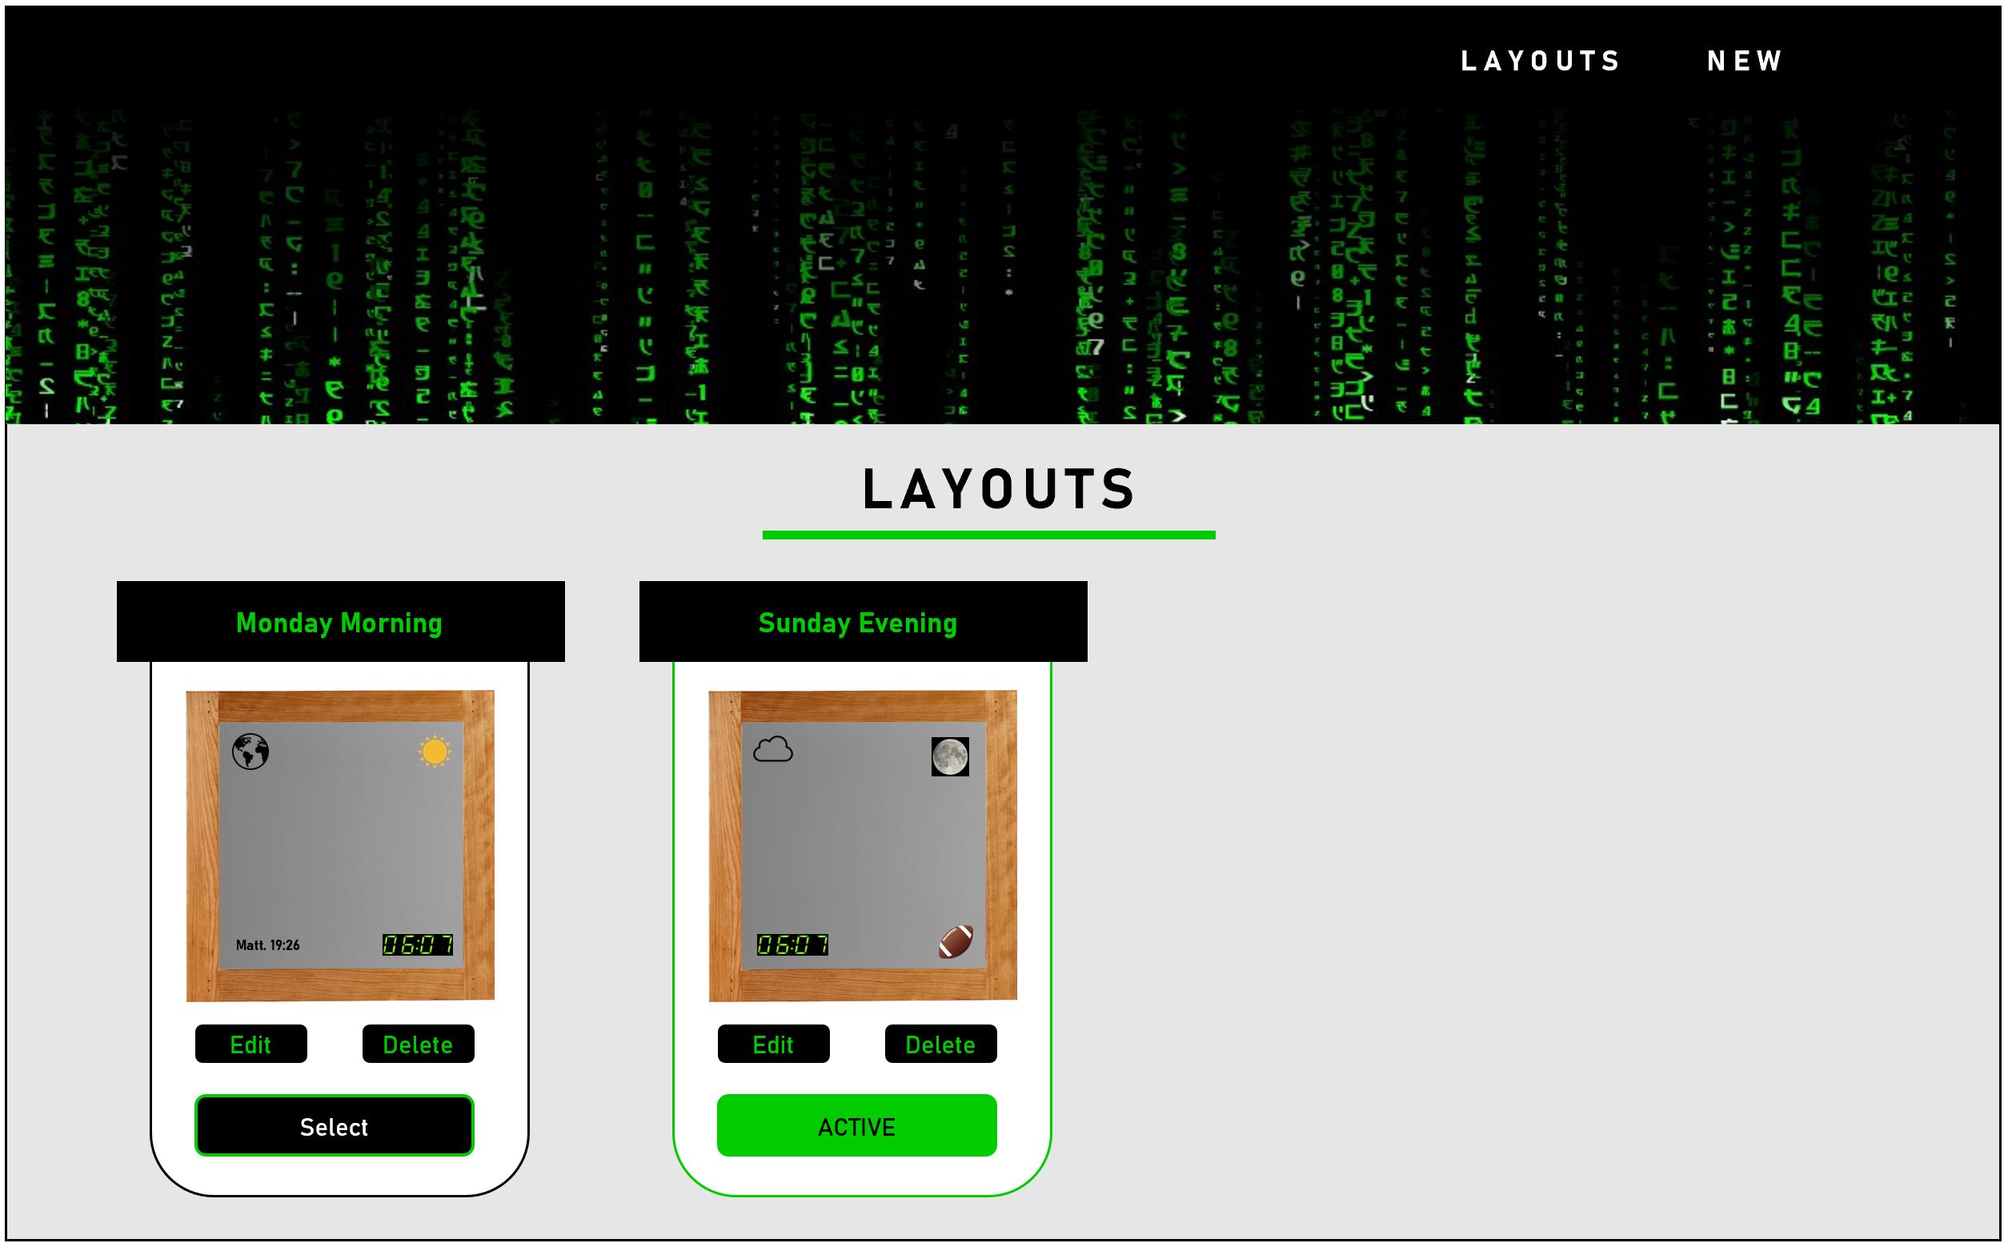

*The user interface design for the all-layouts page, with one layout selected as a display.*

Configure New Layout:

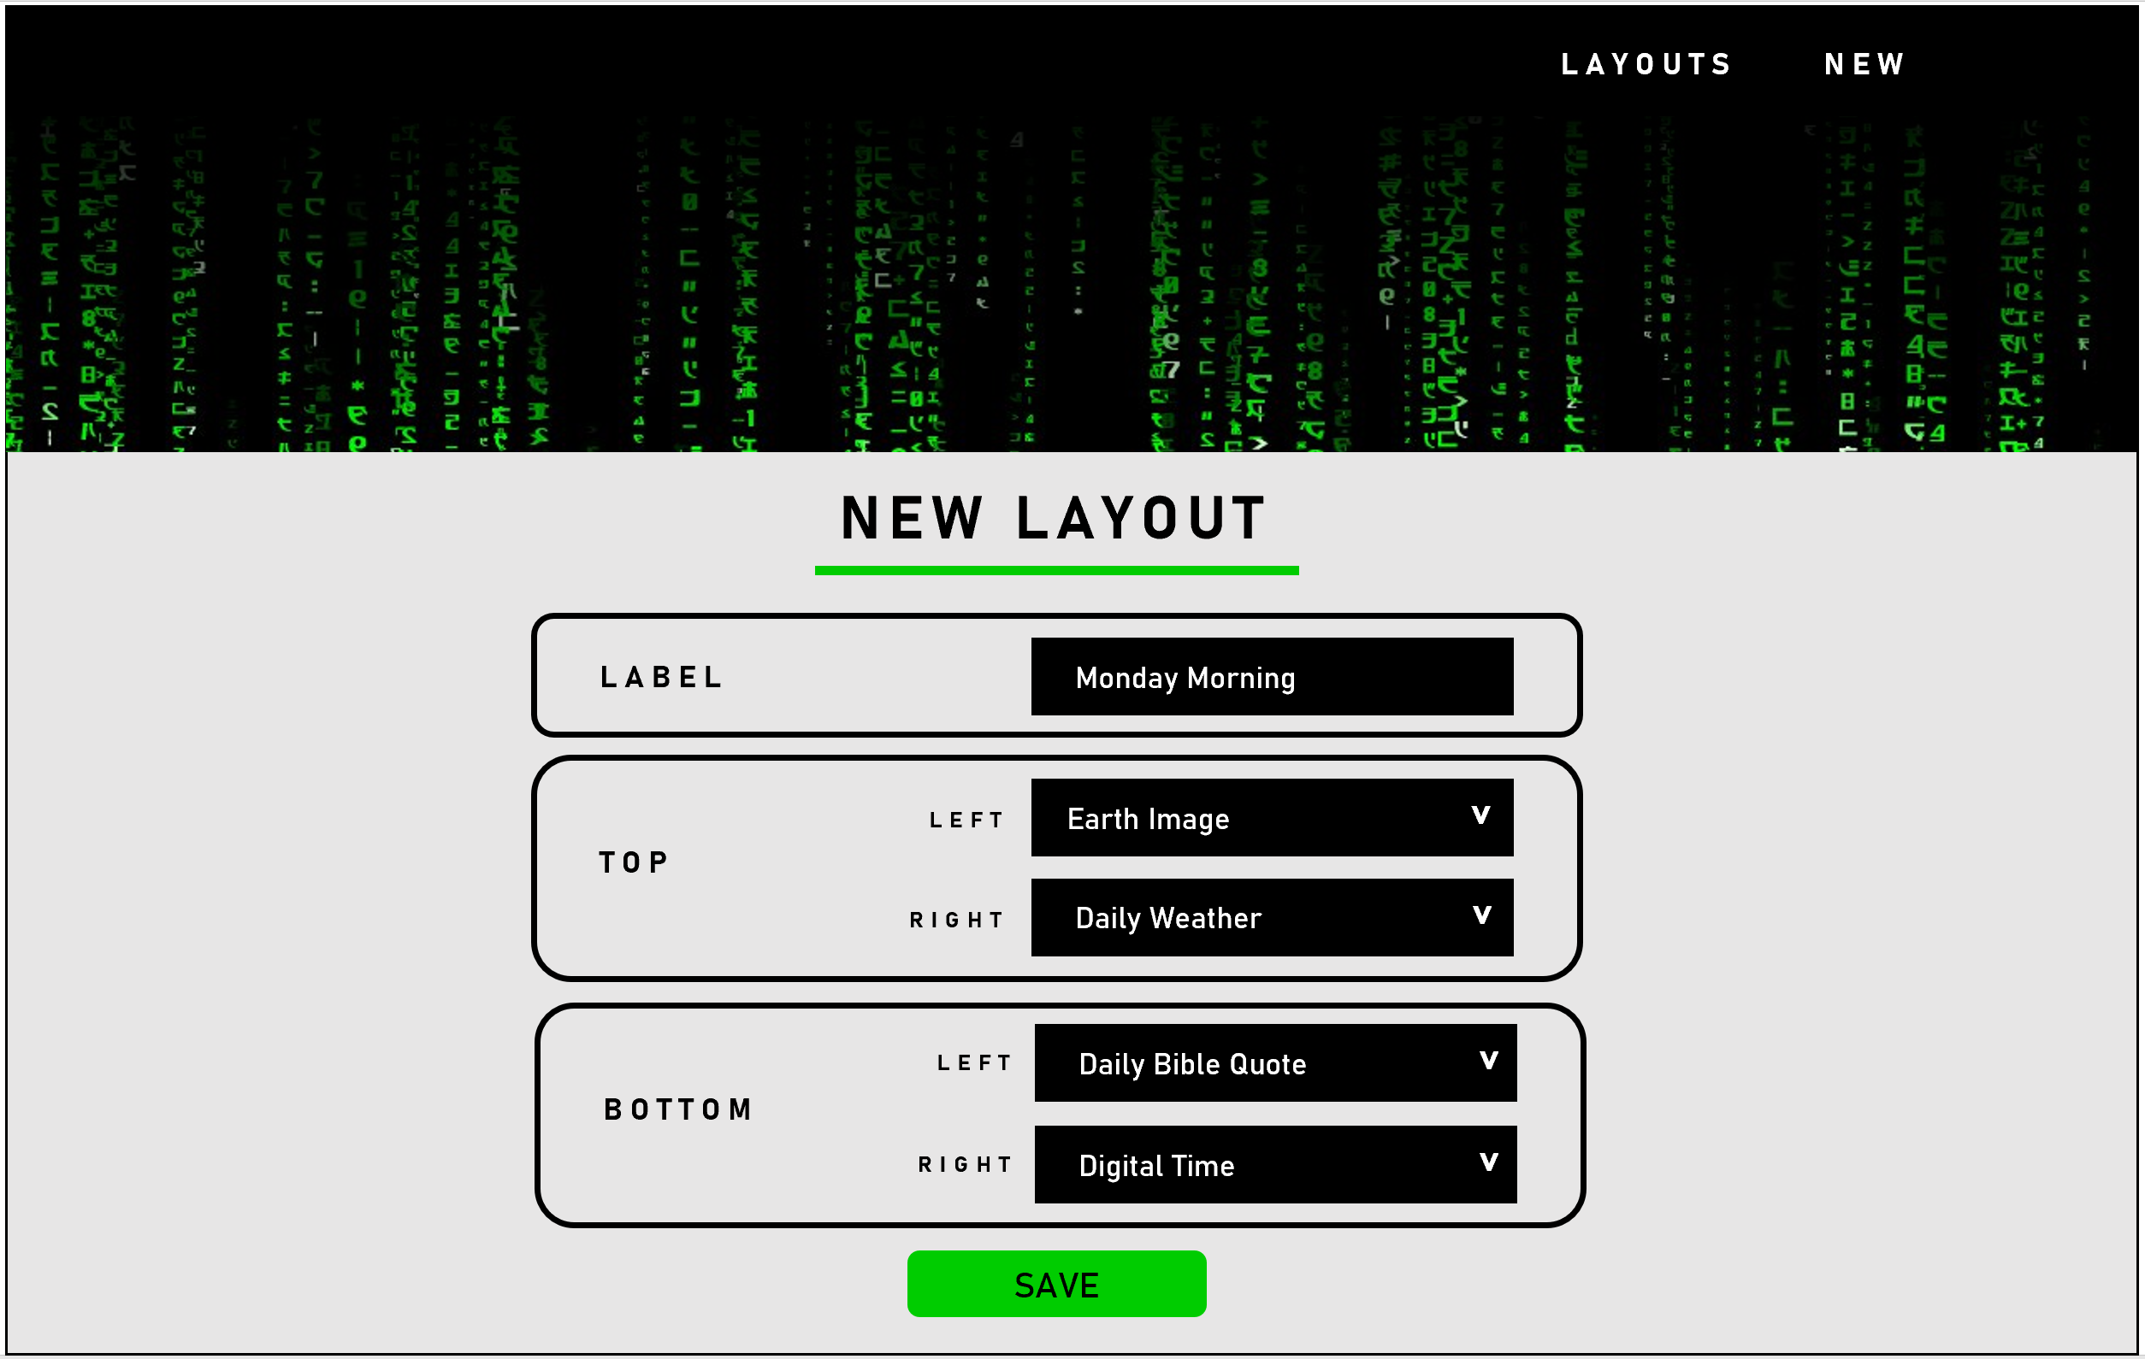

*The user interface design for the new layout page.*

Edit Existing Layout:

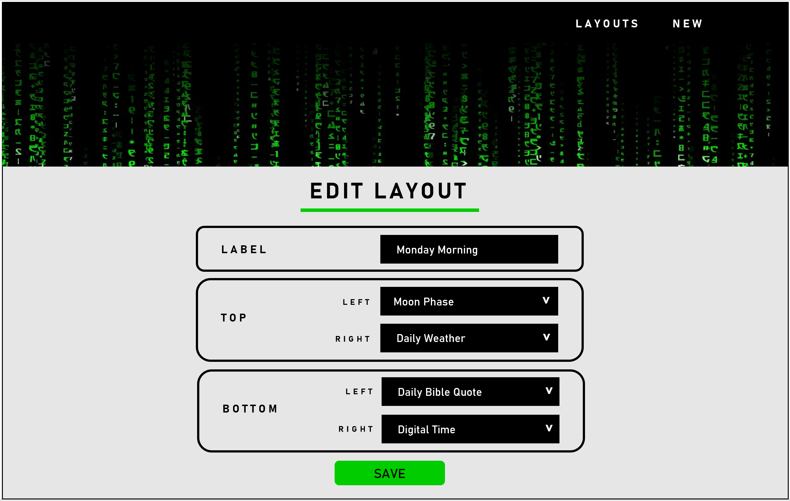

*The user interface design for the edit single layout page.*

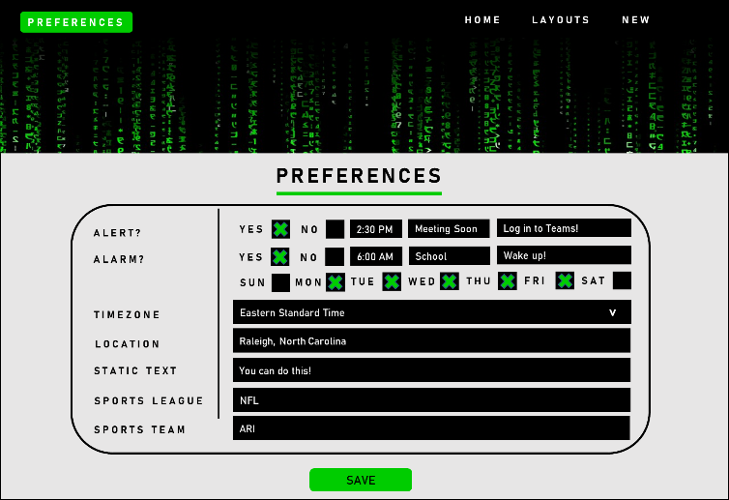

*The user interface design for the specifying preferences page.*

Reports Design

The system does not produce any reports.